Task-01
Output Screenshot:
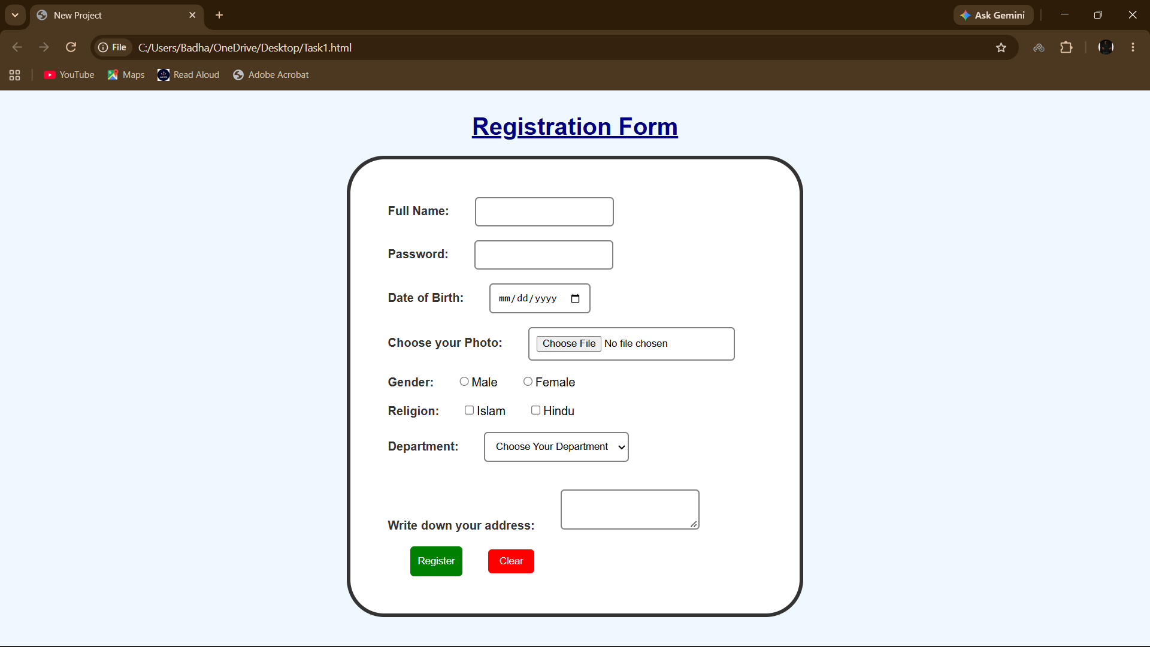
HTML Code:
<!DOCTYPE html>
<html>
<head><title>New Project</title>
<link rel="stylesheet" href ="style.css">
</head>
<body>
<h1>Registration Form</h1>
<form>
<div>
<label for ="fullname"> Full Name: </label>
<input type="text" name ="fullname" id="fullname" required >
</div><br>

<div>
<label for ="password"> Password: </label>
<input type="password" name ="password" id="password">
</div><br>

<div>
<label for ="dob"> Date of Birth: </label>
<input type="date" name ="dob" id="dob">
</div><br>
<div>
<label for ="image"> Choose your Photo: </label>
<input type="file" name ="photo" id="photo">
</div><br>
<div>
<label for ="gender"> Gender: </label>
<input type="radio" id="g1" value="male">Male
<input type="radio" id="g2" value="female">Female
</div><br>
<div>
<label for ="religion"> Religion: </label>
<input type="checkbox" id="r1" value="islam">Islam
<input type="checkbox" id="22" value="hindu">Hindu
</div><br>
<div>
<label for ="department"> Department: </label>
<select name="Department">
<option value="">Choose Your Department</option>
<option value="CSE">CSE</option>
<option value="EEE">EEE</option>
<option value="IPE">IPE</option>
</select></div><br><br>
<div>
<label for ="address">Write down your address: </label>
<textarea col="15" row="20"></textarea>
</div><br>
<div>
<input type="submit" value="Register">
<input type="reset" value="Clear">
</div>
</form>
</body>

CSS Code:
body{
font-family: Arial,san-serif;
margin: 30px;
background-color: #f0f8ff;
}
h1{
color:navy;
text-align:center;
text-decoration:underline;
}
form{
width: 500px;
margin: auto;
border: 5px solid #333;
padding: 50px;
background-color:white;
border-radius: 50px;
}
label{
font-weight: bold;
color: #333;
}
input,select,textarea{
margin-left: 30px;
padding: 10px;
border: 2px solid gray;
border-radius:5px;
}
input[type="submit"]{
background-color:green;
color:white;
border:none;
padding:12px 10px;
cursor: pointer;
}
input[type="reset"]{
background-color:red;
color:white;
border:none;
padding:8px 15px;
cursor: pointer;
}
input[type="submit"]:hover{
background-color:darkgreen;
}
input[type="reset"]:hover{
background-color:darkred;
}

Task 2
Output:
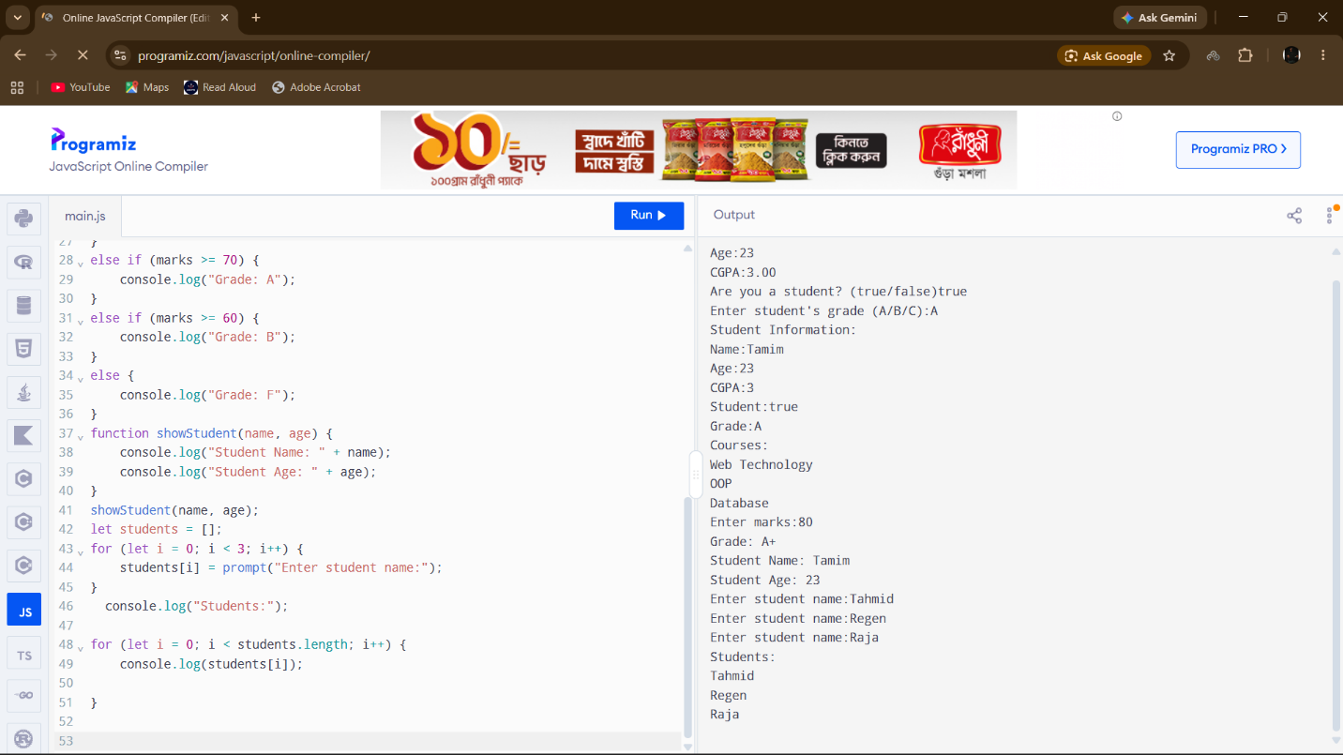
Js Code:
let name = prompt("Name:");
let age = parseInt(prompt("Age:"));
let cgpa = parseFloat(prompt("CGPA:"));
let isStudent = (prompt("Are you a student? (true/false)") === "true");
let grade = prompt("Enter student's grade (A/B/C):").charAt(0);
console.log("Student Information:");
console.log("Name:"+ name);
console.log("Age:"+ age);
console.log("CGPA:"+ cgpa);
console.log("Student:"+ isStudent);
console.log("Grade:"+grade);
let courses = [
"Web Technology",
"OOP",
"Database"
];
console.log("Courses:");
for (let i = 0; i < courses.length; i++) {
console.log(courses[i]);
}
let marks = Number(prompt("Enter marks:"));
if (marks >= 80) {
console.log("Grade: A+");
}
else if (marks >= 70) {
console.log("Grade: A");
}
else if (marks >= 60) {
console.log("Grade: B");
}
else {
console.log("Grade: F");
}
function showStudent(name, age) {
console.log("Student Name: " + name);
console.log("Student Age: " + age);
}
showStudent(name, age);
let students = [];
for (let i = 0; i < 3; i++) {
students[i] = prompt("Enter student name:");
}
console.log("Students:");
for (let i = 0; i < students.length; i++) {
console.log(students[i]);

}

